OOP Assignment 2

**Submitted By : Deepjyoti Deka – 190103014 - 4th Semester (CSE)**

Q1) Write a Program to calculate the age of human by entering date of birth.

#include <iostream>

using namespace std;

int main(){

int current_day , current_month , current_year;

int birth_day , birth_month , birth_year;

int age;

cout << "Enter today day, month and year" <<endl;

cin >> current_day >> current_month >> current_year;

cout << "Enter Birth day , month and year" <<endl;

cin >> birth_day >> birth_month >> birth_year;

if(current_month < birth_month){

age = current_year-birth_year -1 ;

}

if(current_month == birth_month && current_day < birth_day){

age = current_year-birth_year -1 ;

}

else{

age = current_year-birth_year;

}

cout << "Your age is " << age << endl;

}

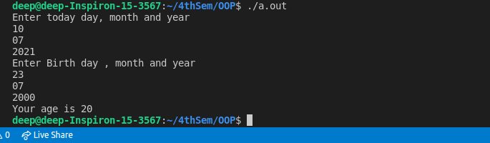

Q2) Write a Program to display the given any number between 1-999 in roman numbers.

#include<iostream>

using namespace std;

string convert_roman(int *num)

{

string roman;

string c[] = {"", "C", "CC", "CCC", "CD", "D",

"DC", "DCC", "DCCC", "CM"};

string x[] = {"", "X", "XX", "XXX", "XL", "L",

"LX", "LXX", "LXXX", "XC"};

string i[] = {"", "I", "II", "III", "IV", "V",

"VI", "VII", "VIII", "IX"};

string hundereds = c[(*num%1000)/100];

string tens = x[(*num%100)/10];

string ones = i[*num%10];

roman = hundereds + tens + ones;

return roman;

}

int main()

{

int num;

cout<<"Enter number to convert in Roman between 1-999: "<<endl;

cin>>num;

cout << convert_roman(&num) <<endl;

}

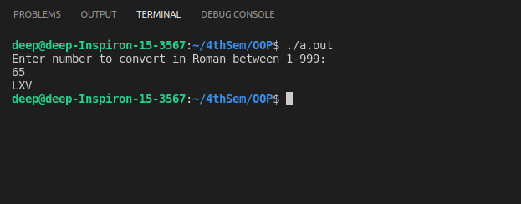

Q3) Program to select an operation from list(factorial, odd/even, prime,raise to power, square root) and display its results.

#include <iostream>

#include <math.h>

using namespace std ;

void factorial(int num){

int answer = 1;

while(num > 0){

answer = answer * num;

num = num - 1;

}

cout << "The factorial is " << answer <<endl;

}

void oddCheck(int num){

if (num % 2 == 0 ) {

cout << "The number is even";

}else{

cout << "The number is odd";

}

}

void prime(int num){

for(int i = 2 ; i < num ; i++){

if(num % i == 0){

cout << "The number is not prime";

return ;

}

}

cout << "The number is prime";

}

void power(int num){

int power;

int answer = 1;

cout << "Enter the power ot raise \n";

cin>>power;

for(int i = power ; i>0 ; i--){

answer = answer * num;

}

cout << answer ;

}

void squareRoot(int num){

cout << "The Square root is " << sqrt(num);

}

int main(){

int num,option;

cout << "Enter the number \n";

cin >> num;

cout << "Select Options" << endl;

cout <<" 1.Factorial \n 2.odd/even \n 3.prime \n 4.power \n 5.Square root \n";

cin >> option;

switch(option){

case 1 :

factorial(num);

break;

case 2 :

oddCheck(num);

break;

case 3 :

prime(num);

break;

case 4 :

power(num);

break;

case 5 :

squareRoot(num);

break;

default :

cout << "Wrong input ";

break;

}

}

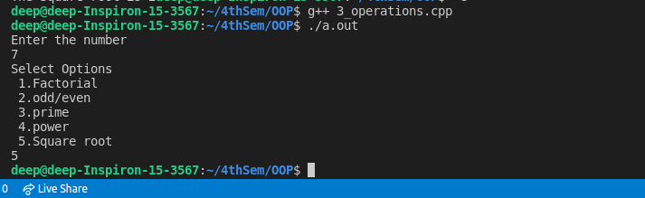

Q4) Program to find out the day of given date starting from Jan. 2001.

# include <iostream>

using namespace std;

int main(){

int d, m, y ,answer;

cout<<"Enter day, month, year to find "<<endl;

cin>>d>>m>>y;

answer = (d += m < 3 ? y-- : y - 2, 23*m/9 + d + 4 + y/4- y/100 +y/400)%7;

switch(answer)

{

case 0:{

cout<<"Sunday"<<endl;

break;

}

case 1:{

cout<<"Monday"<<endl;

break;

}

case 2:{

cout<<"Tuesday"<<endl;

break;

}

case 3:{

cout<<"Wednesday"<<endl;

break;

}

case 4:{

cout<<"Thursday"<<endl;

break;

}

case 5:{

cout<<"Friday"<<endl;break;

}

case 6:{

cout<<"Saturday"<<endl;

break;

}

default:{

cout << "Something went wrong";

break;

}

}

}

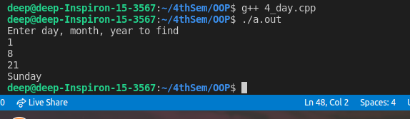

Q5) Program to display the diamond design on screen with star

#include<iostream>

using namespace std;

int main()

{

int len = 4;

int c , k;

for (k = 1; k <= len; k++)

{

for (c = 1; c <= len-k; c++)

printf(" ");

for (c = 1; c <= 2*k-1; c++)

printf("*");

printf("\n");

}

for (k = 1; k <= len - 1; k++)

{

for (c = 1; c <= k; c++)

printf(" ");

for (c = 1 ; c <= 2*(len-k)-1; c++)

printf("*");

printf("\n");

}

return 0;

}

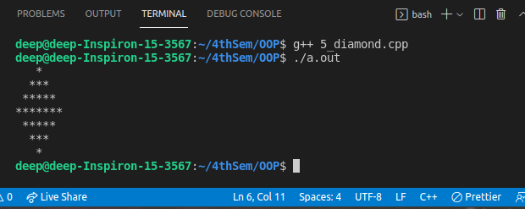

Q6. Program to find out the greater number from a list.

#include <iostream>

using namespace std;

int max(int *a ,int size){

int greatest = a[0];

for(int i=1 ; i< size ; i++){

if (greatest < a[i] ){

greatest = a[i];

}

}

return greatest;

}

int main(){

int n;

cout<<"Enter no of elements in the list: "<<endl;

cin>>n;

int arr[n];

for(int i=0;i<n;i++)

{

cin>>arr[i];

}

cout << "The greatest number is " << max(arr , n) << endl;

}

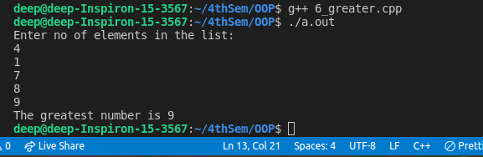

Q7. Program to sort characters in ascending order by using bubble sort.

#include<iostream>

using namespace std;

void bubbleSort(const char a[], char *b , int size){

char temp;

int i,j;

for (i = 0; i < size; i++){

b[i] = a[i];

}

for(i = 0; i < size; i++){

for(j = i + 1; j < size - 1; j++){

if(b[j-1] > b[j]){

temp = b[j];

b[j] = b[j-1];

b[j-1] = temp;

}

}

}

}

int main(){

int size = 5;

char sorted[size];

char letters[size] = {'a','c', 'b','n','z'};

bubbleSort(letters, sorted , size);

for (int i = 0; i < size; i++){

cout << sorted[i] << "\n";

}

}

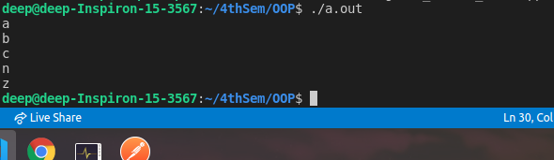

Q8. Program to sort the numbers by using selection sort.

#include <iostream>

using namespace std;

void selectionSort (int *arr, int n)

{

int i, j;

for (i = 0; i < n; ++i)

{

for (j = i+1; j < n; ++j)

{

if (arr[i] > arr[j])

{

arr[i] = arr[i]+arr[j];

arr[j] = arr[i]-arr[j];

arr[i] = arr[i]-arr[j];

}

}

}

}

int main()

{

int n, i;

cout<<"Enter the size of array\n ";

cin>>n;

int array[n];

cout << "Enter the elements: \n" ;

for(i = 0; i < n; i++)

{

cin>>array[i];

}

selectionSort(array, n);

cout<<"Sorted Array are : ";

for (i = 0; i < n; i++){

cout<<array[i]<< ",";

}

}

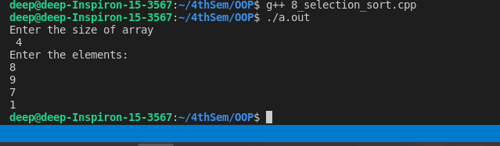

Q9. Program to multiply two matrices.

#include <iostream>

using namespace std;

int main()

{

int a[10][10] , b[10][10] , c[10][10];

int row , column;

cout << "No of rows ? \n";

cin>> row;

cout << "No of column ? \n";

cin>> column;

cout << "Enter the first element \n";

for(int i = 0 ; i < row ; i++){

for(int j=0 ; j < column ; j++){

cin>> a[i][j];

}

}

cout << "Enter the second element \n";

for(int i = 0 ; i < row ; i++){

for(int j=0 ; j < column ; j++){

cin>> b[i][j];

}

};

cout << "Multiply the matrix \n";

for(int i=0 ; i< row ; i++){

for(int j=0 ; j < column; j++){

c[i][j] = 0 ;

for(int k=0 ; k<column ; k++){

c[i][j] += a[i][k] * b[k][j];

}

}

};

cout << "printing the result\n";

for(int i=0 ; i<row ; i++){

for(int j=0; j<column ; j++){

cout << c[i][j] << " " ;

}

cout << "\n";

}

}

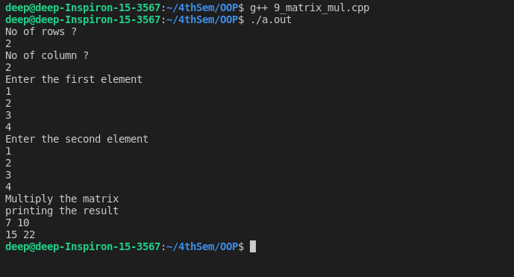

Q10. Print the Alphabet Pattern in Python, as shown below. The input will be a number n, such that 1 <= n <= 26. Input: 5

Output:

A

A B

A B C

A B C D

A B C D E

#include <iostream>

using namespace std;

int main(){

int n;

char character = 'A';

cout<<"Enter the value of n: ";

cin>>n;

for (int i = 1; i <= n; i++) {

for (int j = 1; j <= i; j++) {

cout << char(character + (j - 1))<< " ";

}

cout << "\n";

}

}

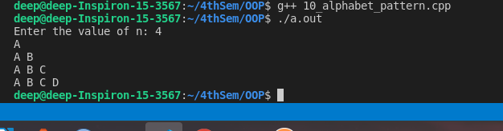

Q11. Write a program to calculate the multiplication of all the prime numbers between 1 and 39 in Fibonacci series.

#include <iostream>

using namespace std;

bool checkPrime(int n , int i)

{

if (n == 0 || n == 1) {

return false;

}

if (n == i)

return true;

if (n % i == 0) {

return false;

}

i++;

return checkPrime(n, i);

}

int fib(int n , int *a){

int insert;

if (n == 1){ return 1;}

if (n == 2 ){return 1;}

a[n] = fib(n-1 , a) + fib(n-2 , a);

return a[n];

}

int main()

{

int a[100];

int i, n;

int answer = 1;

cout<<"Enter the limit of fibonaci series :";

cin>>n;

fib(n , a);

cout << "The prime numbers from fibb are ";

for(int i=3;i<n+1;i++)

{

if(checkPrime(a[i],2)){

cout<<a[i]<<",";

answer *= a[i];

}

}

cout<<"\n Multiplication of prime numbers in fibonaci series :"<<answer << endl;

}

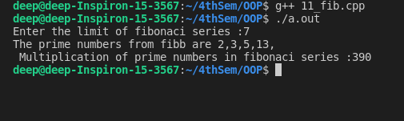

Q12. John is applying for a job but he has some restrictions. He would love to do job in

Mumbai city and accept the job offer if he gets paid over 800000 per year. He does not like Delhi city but he would accept the job offer if he gets paid over 1500000 per year to work there. But in case of Guwahati, he is ready to join company if get he gets paid just over

#include<iostream>

using namespace std;

int main()

{

long int sal_mum=800000,sal_del=1500000,sal_ghy=600000;

int n;

cout<<"Enter salary:\n";

cin>>n;

if(n>sal_del){

cout<<"John will work in guwahati , mumbai , delhi"<<endl;

}

else if(n>sal_mum ){

cout<<"John will work in mumbai and guwahati "<<endl;

}

else if(n>sal_ghy){

cout<<"john will work in ghy"<<endl;

}

return 0;

}

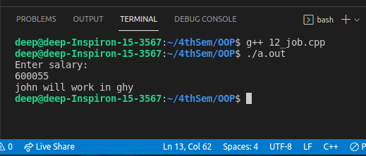

13. You have one two years old computer and you want to sell it. Write a program to find

whether you are in profit or loss after selling your computer.

#include<iostream>

using namespace std;

int main(){

double sell;

double buy;

cout<<"Enter the buy and sell price: ";

cin>>buy>>sell;

if(sell<buy)

{

cout<<"Loss: "<<(buy-sell)<<endl;

}

else if(sell>buy)

{

cout<<"Profit: "<<(sell-buy)<<endl;

}

else

{

cout<<"Neither"<<endl;

}

return 0;

}

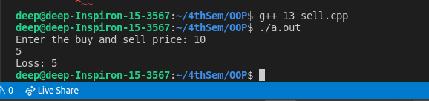

Q14) Write at least two program using function from question no 1 to 13.

#include <iostream>

using namespace std;

int max(int *a ,int size){

int greatest = a[0];

for(int i=1 ; i< size ; i++){

if (greatest < a[i] ){

greatest = a[i];

}

}

cout <<"The maximum integer is " <<greatest <<endl;

}

void selectionSort (int *arr, int n)

{

int i, j;

for (i = 0; i < n; ++i)

{

for (j = i+1; j < n; ++j)

{

if (arr[i] > arr[j])

{

arr[i] = arr[i]+arr[j];

arr[j] = arr[i]-arr[j];

arr[i] = arr[i]-arr[j];

}

}

}

for(i=0 ; i<n ; i++){

cout<< arr[i] <<",";

}

}

int main(){

int n = 6;

int a[] = {5,2,4,5,9,22};

int choice;

cout << "Choose \n 1.Maxium Integer in Array \n 2.Sort the array \n" ;

cin >> choice;

switch(choice){

case 1 :

max(a , n);

break;

case 2 :

selectionSort(a , n);

}

}

